***DAY 6 ASSIGNMENT***

* ***Used ps to search name systemd:***

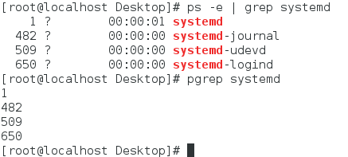

* ***Using terminal to find all the processes associated with the terminal:***

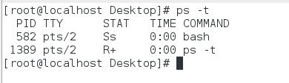

* ***Process id of the shell :***

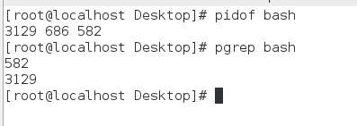

* ***3 instances of sleep in background and the process id of the sleep processes:***

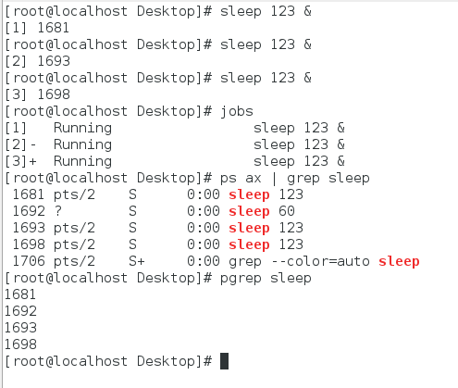

* ***Three processes using top command:***

